From Prediction to Causation: An SCM-Based Explainable AI Methodology for Late-Delivery Analysis in Supply Chains

S. Aswin
Department of Mathematics
Amrita School of Physical Sciences, Coimbatore Amrita Vishwa Vidyapeetham, India cb.ps.p2dls24007@cb.students.amrita.edu

ABSTRACT

A number of supply chain performance factors, such as revenue realization, schedule stability, and service de- pendability, are impacted by delivery delays. Predictive models can classify deliveries as late or on-time but they fail to identify the specific operational factors which caused the delivery delay. The process of identifying risky orders requires more than just finding the dangerous shipment. Decision makers need to understand which op- erational mechanism contributed to the disruption and how changes in those mechanisms would impact delivery results. This study develops a post-hoc explanatory AI (XAI) using a Structural Causal Model (SCM) to inter- pret late delivery predictions. We explicitly define a DAG to represent assumed causal ordering among supplier efficiency, demand pressure, logistics constraints, geographic friction, execution delay, and delivery outcome. Execution delay is treated as a mediator rather than a direct predictor. Structural equations are then estimated to parameterize these relationships. A stochastic formulation incorporates residual uncertainty through additive exogenous noise. For each predicted late order, the model computes mechanism-level contribution scores and identifies the dominant operational driver under the imposed structural specification. We then simulate counter- factual interventions by modifying the dominant mechanism while holding other structural relations invariant, allowing us to evaluate whether the predicted delivery status would change. This procedure is applied to 180,510 transaction records. Evaluation metrics indicate low counterfactual inconsistency and high structural faithfulness under the defined model assumptions. Contribution allocation remains concentrated across mechanisms, and do- main alignment with expert ordering appears stable. These findings suggest that mechanism-level explanations can be derived from transaction-level predictions, although the validity of the explanations depends on the cor- rectness of the assumed causal structure. Counterfactual Consistency Error of 0.0077, Faithfulness of 0.9654, Stability of 0.0005, Sparsity of 0.9779, and Domain Alignment of 0.9800 with all confirmed that the identified mechanisms represent the true and dominant factor providing an explanation of why a delivery failed to be on time.
Keywords: Explainable AI (XAI), Structural Causal Models, Supply Chain Management, Root Cause Analysis, Counterfactual Reasoning

INTRODUCTION

A supply chain resilience has emerged as a persistent challenge in manufacturing industries that operating in a dynamic environment [12]. As the global distribution of sourcing and distributed production chains, coupled with unforeseeable demand volatility, cause the situation, the probability of delivery issues arising increases [12].

Lay a hold on the inventory levels, the production scheduling of the revenue as well as customer satisfaction are adverse consequences of the late delivery of the goods. Organizational functioning is limited by the application of formal risk control since it is used to ensure efficiency in operations. This is because the process of managing delivery risk is now a key to competitive success since supply networks become more interconnected.
The development of predictive analytics has led to better methods which classify delivery risk assessment. The hybrid approach which combines Data Envelopment Analysis and Temporal Convolutional Networks enables supplier efficiency assessment to connect with subsequent temporal pattern learning [8]-[11]. The researchers developed a DEA–TCN framework for late delivery prediction which they demonstrated through their research work [10].
The use of post-hoc explanation techniques such as LIME and SHAP enhances the ability to understand results but these methods depend on correlation data which fails to demonstrate cause-effect patterns or permit interven- tion studies [13]–[17]. The complex supply chain environments restrict their ability to support decision-making processes.
Structural Causal Models provide a formal framework for representing cause effect relationships through their use of directed acyclic graphs and structural equations [1], [2]. The framework enables researchers to break down prediction results into understandable causal pathways which reveal hidden variables that affect system performance. SCM enables counterfactual reasoning which lets users assess how results would differ when test- ing different operational conditions [2], [3]. Existing supply chain research shows limited progress in combining SCM with hybrid predictive models which assess delivery risk.
The study creates a post-hoc causal explanation framework which uses a continuous DEA–TCN prediction sys- tem to solve the existing research problem. The framework models key operational mechanisms supplier ef- ficiency, demand complexity, pricing pressure, logistics constraints, geographic friction, execution delay, and delivery risk within a multistage SCM. The system uses three methods which include structural modeling and stochastic analysis together with counterfactual reasoning to determine main reasons behind delivery delays while assessing how different interventions impact results. The system uses delivery risk prediction to create an analysis method which examines operational processes at their fundamental level while pinpointing all high-risk transactions together with their associated operational causes.

LITERATURE REVIEW

Mastoor M. Abushaega, Osamah Y. Moshebah, Ahmed Hamzi, and Saleh Y. Alghamdi [13] put forward a hybrid DEA–TCN architecture that combines the Banker–Charnes–Cooper Data Envelopment Analysis model with a Temporal Convolutional Network for predicting late deliveries. Structured inputs to the TCN come from supplier-level DEA efficiency scores, which get 99% of the classifications right. The framework shows that it can make good predictions, but the model only gives binary outputs, which makes it hard to show how risk changes over time. Most importantly, the method does not explain how the operational mechanisms that cause delivery delays work.
Jomthanachai, Suriyan and Wong, Wai-Peng and Lim, Chee-Peng [8] showed that machine learning classifiers can use DEA-derived efficiency scores obtained from operational risk assessment as comprehensible and useful operational performance indicators. The methods developed in this research study concentrate on performance evaluation through efficiency assessment which researchers use as an explanatory element instead of building a detailed system that depicts operational connections.
Jin, Tian [11] introduced an attention-based Temporal Convolutional Network which they combined with rein- forcement learning to achieve delay prediction and inventory optimization. Their results show that TCN archi- tectures effectively capture long range temporal dependencies but the model operates as a black-box predictor

which fails to show how operational variables interact to affect delivery outcomes.
Dutta, Gourab, and Sardar, Debabrata, Vasumathi, B., and Kavitha, P. [20] proposed an IoT-based intelligent delivery service model for perishable food logistics, incorporating sensor data, edge processing, and hybrid ma- chine learning techniques to assess quality and forecast spoilage risk. The research underscores the significance of real-time tracking and predictive monitoring in delivery systems. But the main focus is still on keeping an eye on the environment and predicting spoilage, not on figuring out why deliveries are late or what causes them.
Judea Pearl [1] developed Structural Causal Models (SCM) as a formal system to define cause-and-effect rela- tionships through the use of directed acyclic graphs and structural equations. The framework enables intervention analysis and counterfactual reasoning, however, its integration with hybrid efficiency deep learning prediction models for supply chain delivery risk analysis remains limited.
Marek Pawlicki, Aleksandra Pawlicka, Federica Uccello, Sebastian Szelest, Salvatore D’Antonio, Rafal Kozik, and Michal Choras´ [19] talked about how important it is to use metrics like faithfulness, sparsity, stability, and domain alignment to evaluate explainability from many angles. Their viewpoint underscores the necessity of evaluating explanation quality beyond mere predictive accuracy, despite the fact that systematic assessment of explanation quality has not been extensively integrated into supply chain risk prediction research.
The current explainable AI frameworks like SHAP and LIME offer the feature importance by approximating it based on perturbation, however, they depend on statistical associations and not real causal links. Attention based and graph based explanation methods are also similar in that they find influential variables without intervention analysis. Strict Causal Models overcome this shortcoming by to model cause effect dependencies and make counterfactual arguments. This causal proposal makes it possible to interpret the mechanism level of reason besides the correlation based explanation.

PROPOSED METHODOLOGY

The structure is a combination of prediction and causal explanation in two related modules. The former module relies on a DEA-TCN model to determine the risk of late deliveries. The second module explains the result of the predicted risk by means of a SCM to comprehend the cause of mechanisms and assess hypothetical intervention in operations. The workflow also has a sequence of data preparation towards the prediction and then causal interpretation.
The first step is to prepare the supply chain dataset by dealing with missing values, normalizing the data, and turning transaction records into supplier-wise time sequences. From the raw dataset, six operational mechanism variables are derived Supplier Efficiency, Execution Delay, Demand Complexity, Pricing Pressure, Logistics Constraints, and Geographic Friction. These variables are consistently employed across both layers and represent operational factors that affect delivery performance in practice.
The predictive layer uses a hybrid DEA-TCN. Using an input-oriented Data Envelopment Analysis model with variable returns to scale based on the Banker formulation, we first estimate supplier efficiency. This model gives us continuous efficiency scores between 0 and 1. These scores, along with the other operational variables, are fed into a Temporal Convolutional Network that uses sequential transaction data to capture supplier-specific temporal behaviour. Through a sigmoid activation layer, the TCN gives continuous probabilities of late delivery risk. Instead of using a set classification threshold, the raw probability values are kept to allow for later causal interpretation.
The explainable layer brings on a post hoc causal study on a three stage Structural Causal Model. The former phase stipulates causal associations based on a Directed Acyclic Graph in which execution delay serves as an intermediary between upstream activities and the results of delivery. The latter step approximates the structural equations in order to measure the causal effects but during the interpretation of the fixed prediction of the predic-

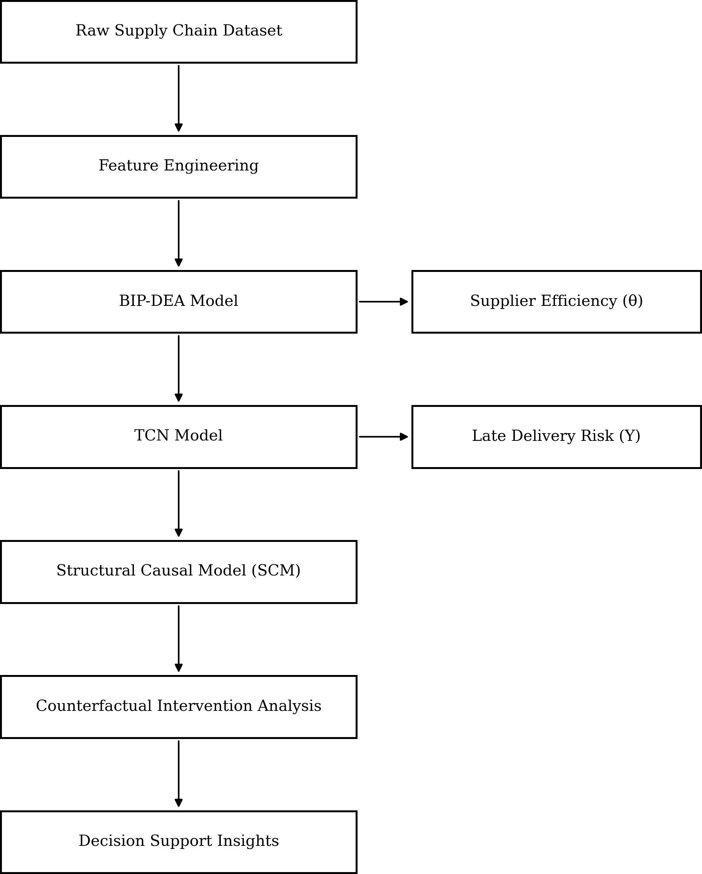

Figure 1: Illustrates the conceptual workflow of the proposed framework.

tive layer. The third phase includes the latent uncertainty and calculates normalized attribution scores in order to identify mechanism-level contributions to each prediction. Counterfactual analysis also compares the ability of the simulated treatment of dominant causal variables on the risk of delivery. This method is related to the causal interpretation and operation decision support in addition to prediction.
Figure 1 shows the conceptual map of the proposed causal explainable risk of late delivery analytical pipeline. Prediction and causal interpretation are combined into a single structure of the workflow. The DEA-TCN module will create continuous scores of supplier efficiency and probability of delivery risks, which will then be analysed with Structural Causal Model (SCM). The SCM allows attribution to be done on a mechanism level, and facili- tates the use of counterfactual intervention analysis, to gain insights into changes to operational conditions which affect predicted delivery risk.

Dataset Description

The proposed study utilizes the SupplychainRiskPredictionDataset, which contains 180,510 supply chain trans- action records. The dataset contains logistical, financial, and operational characteristics and records interactions between suppliers and customers. Order date, shipping date, delivery status, shipping mode, and related cus- tomer data are all recorded for each transaction. Delivery performance and schedule deviation can be measured using operational variables like actual shipping days and scheduled shipping days. Within the simulated sup- ply chain environment, these fields facilitate quantitative evaluation of execution delay and shipment reliability. Every transaction has an economic context provided by financial metrics like profit ratio, discount rate, sales per customer, and benefit per order. The dataset allows for a comprehensive evaluation of operational efficiency

and the risk of late delivery by combining supplier performance indicators with transactional and logistics data. The chosen variables demonstrate operational attributes which supply chain sectors use as standard operational characteristics, which supports the framework’s ability to be implemented beyond the research dataset that this study examines.

Data Preprocessing

The transaction-level dataset was prepared to match the predetermined causal mechanisms before the SCM was built. In order to guarantee complete data for structural equation estimation, missing numerical observations were addressed through controlled substitution. Because the SCM requires fully observed variables for param- eterization, this step was required. The mechanism-level variables that represent supplier efficiency, execution delay, demand complexity, pricing pressure, logistics constraints, and geographic friction were mapped from raw operational attributes. To facilitate quantitative modeling, categorical variables such as market region and shipping mode were converted into ordinal numerical forms. Logarithmic scaling was used to modify a few variables with skewed distributions in order to lessen leverage effects and moderate variance.
Before structural estimation, z-score normalization was used to standardize all constructed mechanism variables. Instead of categorized into a binary label, the predicted late delivery risk probability generated by the DEA–TCN model is kept as a continuous outcome variable within the causal framework.

Handling Missing Values

To guarantee complete observations for regression modeling, missing values in numerical attributes were filled in using controlled substitution. To ensure computational stability, column-wise imputation was carried out using predetermined default values. Shipping duration fields were replaced with zero when missing. Order quantity was substituted with one to preserve multiplicative consistency in feature construction. Missing sales values were assigned a baseline constant to avoid undefined logarithmic operations. Discount rate and profit ratio were replaced with conservative defaults to prevent extreme distortion in pricing-related mechanisms. Geographic coordinates were imputed with zero when unavailable.

Feature Engineering

Feature engineering converts the raw transactional attributes into structured variables that reflect operational mechanisms that affect the performance of delivery. Instead of using actual attributes from raw data, derived variables are prepared to reflect the capability of suppliers, operational burden, financial burden, urgency in logistics, and geographical impact. These engineered variables are used to provide an interpretable representation of the behavior of the supply chain and are then used as input to the SCM.
Six causal mechanism variables are constructed from the dataset.

Supplier Efficiency (E) The calculation of Supplier Efficiency (E) uses an input-oriented BCC Data Envel- opment Analysis model. The DEA formulation assesses the operational performance of suppliers through their ability to transform operational inputs into delivery results. The system uses total shipping duration and cost proxy as inputs while measuring on-time delivery rate and sales contribution as outputs. The efficiency score θ ∈ [0, 1] shows the operational capacity of suppliers in relation to other suppliers.

Execution Delay (D) Execution delay represents the deviation between actual and planned shipping duration and acts as the mediator variable in the causal structure. The calculation for this value starts with:

D = max(0, S_{real} − S_{scheduled}) (1)

The equation uses S_{real} to represent actual shipping days and S_{scheduled} to represent planned shipping days. The clipping operation ensures that early deliveries are not treated as negative delays. This variable captures operational disruptions which occur during order fulfillment.

Demand Complexity (Q) The supply chain experiences operational demands which depend on two factors: order volume and transaction value. It is defined as:

Q = Quantity · ln(1 + Sales) (2)

The logarithmic transformation reduces the influence of extreme sales values while preserving relative ordering. The variable shows how operational pressure increases when customers place large or high-value orders.

Pricing Pressure (P ) Pricing pressure captures financial stress that results from discounting methods and decreased profit margins.

P = DiscountRate · (1 − ProfitRatio) (3)

The combination of higher discount rates and lower profit margins creates greater financial pressure, which can disrupt supply chain operations and decrease delivery performance.

Logistics Constraints (L) The operations of logistics systems become restricted through their need to handle different shipment speeds and various package sizes. Shipping modes are ordinally encoded to reflect urgency levels:

4 Standard Class

ShippingMode = 3 Second Class
2 First Class

1 Same Day

(4)

The logistics constraint variable is then computed as:

L = ShippingMode + ln(1 + Quantity) (5)

This formulation combines delivery urgency and shipment volume to reflect operational complexity in logistics planning.

Geographic Friction (G) Geographic friction measures how spatial and regional factors impact delivery suc- cess across different locations. Market regions are encoded numerically:

1 US

2 LATAM

Market =

The geographic friction variable is computed as:
3 Europe
4 Pacific Asia
5 Africa
(6)

G = Market +
ln(1 + |Latitude| + |Longitude|) 10
(7)

The logarithmic scaling method decreases the effect of extreme coordinate values but still allows for spatial range identification. The constructed variables provide a summary of essential operational processes that determine delivery results. The model converts basic transactional data into understandable cause-and-effect elements which permit systematic evaluation of how supply chain factors impact predictions for late deliveries.

Data Transformation, Data Cleaning, and Feature Selection

The dataset was prepared to ensure suitability for causal modeling and predictive analysis. The process involved two main tasks which included cleaning of raw transactional records and transforming categorical variables into standardized numeric formats while constructing and selecting essential features needed for the proposed framework.

Data Cleaning The initial assessment of the dataset involved checking for missing values and reviewing the inconsistent entries and invalid records. The team used default replacements and statistical imputation methods to address missing values in numerical attributes. The shipping variables underwent validation testing to verify their logical consistency while the team corrected any detected unrealistic or negative values. The system converted negative delivery values from early deliveries into zero value because only actual delivery delays needed to be maintained.

Data Transformation Nominal variables like the Shipping Mode and the Market Region variables went through a transformation to ordinal numerical values so that mathematical operations could be performed on them when the model was being trained. The use of logarithmic transformations was done on sales and order quantity among others using the functionality.

f (x) = ln(1 + x) (8)

to smoothen skewness and level off the big swings in transaction data. Continuous variables were then standard- ized in order to have similar scales of various features in training model.

Feature Selection The selection of features was made to have variables that make a significant contribution to the dynamics of supply chain operation and prediction of late delivery. Characteristics that are associated with

shipping time, quantity of orders, attributes of pricing, geographical location and supplier performance were chosen as the major variables to be further engineered in terms of features. The proposed SCM is based on these features as the variables of the causal mechanism are constructed.

Prediction Layer

The DEA-TCN model receives the data after preprocessing to predict late delivery of the key customer data. In line with the hybrid architecture introduced by Mastoor M. Abushaega, Osamah Y. Moshebah, Ahmed Hamzi, and Saleh Y. Alghamdi [10], the present paper is a synthesis of Data Envelopment Analysis (DEA) to estimate supplier efficiency with the assistance of a Temporal Convolutional Network (TCN) to analyze the temporal sequence. In such a design, DEA measures the performance of suppliers in terms of continuous efficiency scores, whereas the TCN measures time specific dependencies of suppliers based on sequence transaction data. This study does not use a binary scoring approach as in the original formulation but instead uses a sigmoid activation function as the final output layer in order to obtain continuous estimates of probability of late delivery risk. Maintaining probability values, instead of some fixed decision threshold, enables the model to maintain risk variance across observations and to sensibly be combined in the next Structural Causal Model (SCM) [6].

Explainable Layer

The explainable layer takes late delivery risk predictions that are produced by the DEA-TCN model and interprets them through a causal reasoning approach. Since the predictive models only provide limited transparency for operational decision-making, this work will instead use a post-hoc explainable approach based on SCM), which are grounded in the theory of causal inference developed by Judea Pearl [1], [2]. The explainable layer is focused on the process of identifying the underlying operational drivers of predicted risk and translating model outputs into interpretations of decision making for supply chain decision making. To attain this goal, SCM based analysis is used to quantify the causality among operational variables, interpret prediction at the mechanism level and assess what if actionable situations through counterfactual reasoning. Together, these steps give a brief insight into the risk delivery drivers and underpin more informed operational interventions [7], [14].

Structural Causal Model

The Structural Causal Model (SCM) serves as the primary explainable component which researchers use to study the causal connections that lead to late delivery risk predictions. The SCM represents assumed cause–effect rela- tions through a Directed Acyclic Graph (DAG) model. The system uses nodes to show operational mechanisms and directed edges to demonstrate structural dependencies needed for causal analysis [3], [4]. The study uses Execution Delay as a mediator that connects upstream operational conditions to late delivery risk. The SCM framework operates in three separate stages. The acyclic stage establishes the causal framework while the pa- rameterized stage uses structural equations to assess connection strength between different variables. This struc- tured approach helps identify dominant risk drivers and supports counterfactual analysis for decision-oriented evaluation [6], [7].

Acyclic SCM The acyclic SCM defines the causal structure which predicts late delivery risk through its use of a DAG model. A DAG represents cause–effect relationships among operational variables while preventing feedback loops, enabling consistent interpretation of causal pathways [3], [4]. Figure displays the causal structure which this research employs for its computation (Fig. 2).
The DAG construction uses domain knowledge to establish connections between Supplier Efficiency (E) and Demand Complexity (Q) and Pricing Pressure (P) and Logistics Constraints (L) and Geographic Friction (G)

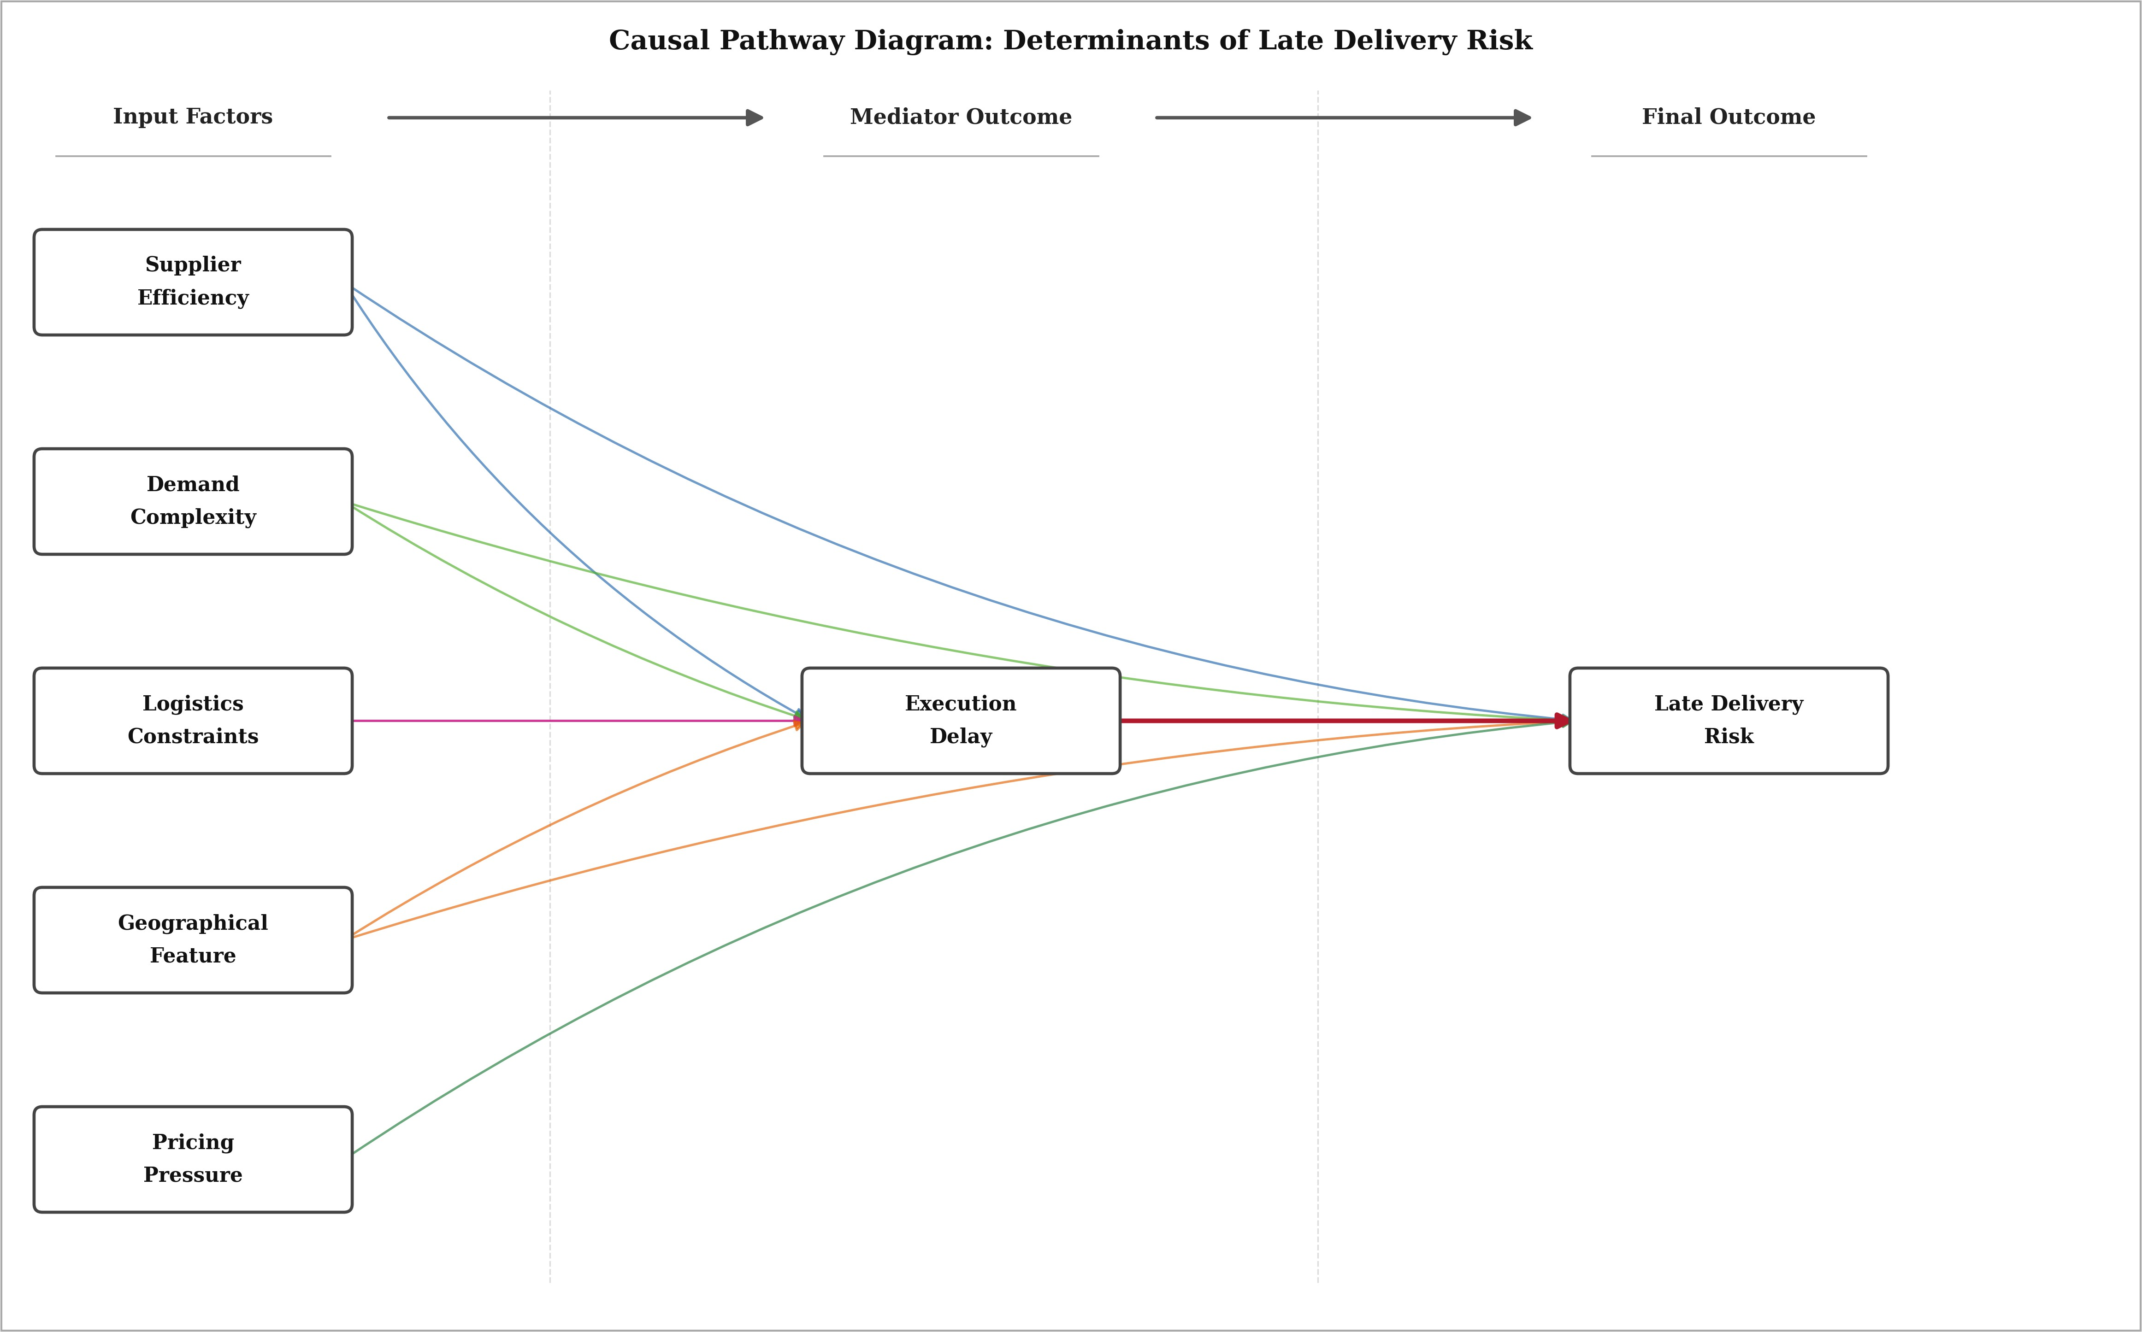

Figure 2: DAG representing causal relationships among operational variables.

and Execution Delay (D) and Late Delivery Risk (Y). Execution Delay results from Supplier Efficiency and Demand Complexity and Logistics Constraints and Geographic Friction, which also impact Late Delivery Risk through their direct effects. Pricing Pressure directly affects Late Delivery Risk but does not influence Execution Delay. Execution Delay serves as the mediator which connects upstream operational conditions to delivery out- comes. The acyclic property guarantees that closed causal loops do not exist while the system meets topological ordering requirements. This causal structure provides the foundation for estimating structural relationships and interpreting causal effects in later SCM stages.

Parametrized SCM The second stage of the explainable framework uses parameterized SCM to measure the causal links which the acyclic model establishes. The structural equations represent the directional dependen- cies defined by the DAG. The researchers chose linear regression to estimate structural parameters because they wanted to observe causal relationships instead of achieving the best predictive results [6]. The two structural equations estimate the causal relationship which the DAG establishes. Execution Delay operates as an endoge- nous mediator which Supplier Efficiency and Demand Complexity and Logistics Constraints and Geographic Friction affect. The mediator equation is expressed as:
D = β₀ + β₁E + β₂Q + β₃L + β₄G + U_{D} (9)

The letter D in this section stands for Execution Delay while E represents Supplier Efficiency and Q shows Demand Complexity and L denotes Logistics Constraints and G stands for Geographic Friction and U_{D} shows the remaining unexplained portion. The model which predicts Late Delivery Risk depends on Execution Delay together with operational variables which affect through both direct and mediated pathways.
Y = γ₀ + γ₁D + γ₂E + γ₃Q + γ₄P + γ₅L + γ₆G + U_{Y} (10)

The DEA–TCN model provides the probability of late delivery risk which is represented by the variable Y while P stands for Pricing Pressure and U_{Y} indicates unobserved influences. Z-score normalization standardizes all continuous variables to standardize coefficient estimation results.
x − µ

xnorm = σ
(11)

Even though linear structural equations offer easy interpretation of causal coefficients, nonlinear behaviour can

be used to operationally define relationships within the supply chain systems. An example is that the effects of logistics limitations on execution delay can rise disproportionately as the urgency of shipments is above capacity constraint, and declining and less growth in supplier efficiency can result in less marginal reduction of late delivery risk beyond some point of operation. Such effects may be more flexibly represented with nonlinear Structural Causal Models that rely on a kernel regression, generalized additive models or a tree-based approach. In this research, however, linear regression will be used to preserve transparency of causal parameters as well as allow compatibility with counterfactual estimation through a fixed structural specification.
The estimated coefficients (β, γ) quantify the strength and direction of influence that operational factors exert on Execution Delay and Late Delivery Risk. The structural equations describe direct effects and indirect effects which operate through the mediating variable. This structure allows predictions to be divided into specific mechanism-level effects which will be used in the upcoming phase.

Stochastic SCM The stochastic Structural Causal Model is the third stage in the framework and it generalises the parameterized SCM model by adding uncertainty to the model used to explain the predictions. While the structural equations describe systematic causal relationships between operational variables, actual supply chain outcomes are also affected by unobserved forces such as temporary disruptions, inefficiencies in coordination and variability in demand. To cover such effects the stochastic SCM in which disturbance terms are introduced and the predictions are split in terms of the causal contribution of the mechanisms, making it possible to find what is supposed to be the dominant causative driver for each order.
Uncertainty is included by means of an abduction step, the order-specific disturbances are recovered from ob- served data. For every observation, disturbances are calculated as the difference between observed and predicted values calculated from the structural equations:

U_{D}[i] = D_{observed}[i] − D_{predicted}[i], U_{Y} [i] = Y_{observed}[i] − Y_{fitted}[i] (12)

The disturbance terms maintain their stochastic properties for every observation while they enable predictions to be explained through actual operational conditions instead of using deterministic relationships. The study uses deviation-based normalization to measure mechanism-level contributions because it allows researchers to assess the extent of actual system behavior differences from standard operational patterns. The contribution score for any variable x is calculated through the use of interquartile range normalization.

C(x_{i}) =
|x_{i} − median(x)| (13)
IQR(x)

The developed formula maintains stability under different variable conditions while showing decreased reaction to extreme values. The uncertainty component derived from the outcome disturbance is included with reduced scaling to prevent unexplained variation from dominating the explanation. Global structural importance is incor- porated using coefficient weights obtained from the outcome equation:

|γ_{i}|

w_{i} =
Σ
j
(14)
|γ_{j}|

The final mechanism contribution combines deviation magnitude with structural relevance:

final
C(x_{i}) w_{i}

Ci =
Σ
k
C(x_{k}
) w_{k}
(15)

The dominance of each causal mechanism towards each observation is determined by the variable having the highest normalized contribution. This formulation allows for case level interpretation of the delivery risk predic- tions whilst preserving the consistency of the structural equations. In most cases, contributions are concentrated to the one primary mechanism, which suggests that late delivery risk is usually due to one operational factor be- ing dominant and equally impacting all of the variables. These explanations at the level of mechanisms, support the following counterfactual analysis in terms of which of the structural changes it is most likely to reduce the delivery risk.

Counterfactual Analysis

Counterfactual analysis complements the Structural Causal Model because it would assess change in the pre- dicted delivery risk if hypothetical operational interventions were undertaken. While SCM identifies the mech- anisms that are responsible for each prediction, counterfactual reasoning provides an estimate of the impact of modifying these mechanisms, while preserving the structure relationships that were expressed in the model. This enables causal explanations to be realized into decision-oriented what-if insights.
For every observation i, the causal effect of an intervention is defined as:

CEi = Yobserved,i − Ycf,i (16)

where Y_{observed,i} represents the original predicted risk. Y_{cf,i} is the intervention predicted risk. A positive value means a decrease in the risk for late delivery.
The counterfactual outcomes are calculated by propagating interventions using the structural equations of the SCM. When upstream mechanisms are being modified, the mediator (Execution Delay) is recomputed first and then estimation of the outcome of the two from the structural outcome equation with a preserved disturbance term (a recovery disturbance term). This is to ensure that counterfactual predictions are consistent to the causal structure and operational variation is realistic.
Interventions are applied to dominant causal mechanisms identified under the stochastic SCM, it could be an adjustment to exogenous variables or direct modification of the mediator. Retaining disturbance terms does both preserve observation-specific variability and avoid results in the counterfactuals that are unrealistic average conditions. This allows assessment of the effects of focussed operational adjustments that may minimise the predicted late delivery risk.

Table 1: Notation used in the SCM framework

Symbol Definition
E Supplier Efficiency
Q Demand Complexity
P Pricing Pressure
L Logistics Constraints
G Geographic Friction
D Execution Delay
Y Late Delivery Risk
U_{Y} Outcome disturbance
CE_{i} Causal effect of intervention
Y_{cf} Counterfactual predicted risk

RESULT

This model can be applied in real-time supply chain systems where new transactions are assessed as they come in, like order tracking or logistics monitoring platforms. Instead of acting as explanations in and of themselves, it offers continuous estimates of delivery risk and supplier efficiency, which are then utilized as inputs for the causal analysis stage. The confusion matrix (Fig. 3) displays an overall accuracy of 97.25%, with the majority of on-time and late deliveries correctly identified. Although there are still some misclassifications, they are comparatively rare, indicating that the model can fairly accurately represent the underlying temporal delivery behavior.
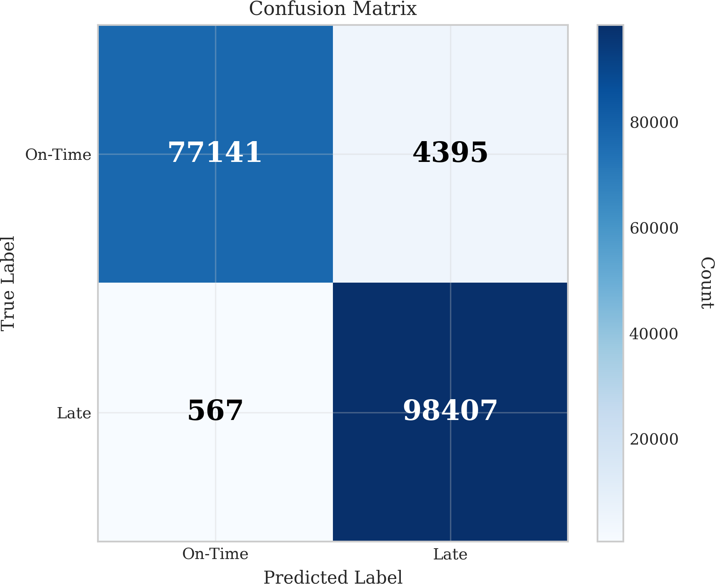

Figure 3: Confusion Matrix representing classification behaviour of the model

The pie chart (Fig. 4) shows how the predicted delivery risk is spread out across the dataset. The results show that 55.6% of orders are considered late deliveries, while the other 44.4% are considered on-time deliveries. This distribution shows how the dataset works and proves that the model keeps the underlying risk structure instead of making predictions that are too balanced. These findings confirm that the DEA–TCN model provides a stable prediction layer, which serves as the input for the SCM-based explanation framework.

Table 2: DOMINANT CAUSE OBTAIN USING SCM
Order ID Supp Efficiency Execution Delay Demand Complexity Pricing Pressure Logistics Constraints Geographic Friction Uncertainty Dominant Cause
75483 | 0.2834 | 0.1626 | 0.0532 | 0.2332 | 0.0722 | 0.0766 | 0.1188 | Supplier Efficiency
75484 | 0.2872 | 0.0161 | 0.0539 | 0.4314 | 0.0722 | 0.0795 | 0.0596 | Pricing Pressure
75485 | 0.3197 | 0.0161 | 0.0598 | 0.0962 | 0.3458 | 0.0972 | 0.0652 | Logistics Constraints
75486 | 0.3151 | 0.2025 | 0.0589 | 0.1110 | 0.0722 | 0.0983 | 0.1419 | Supplier Efficiency
75487 | 0.3069 | 0.1922 | 0.0574 | 0.1397 | 0.0722 | 0.0957 | 0.1358 | Supplier Efficiency
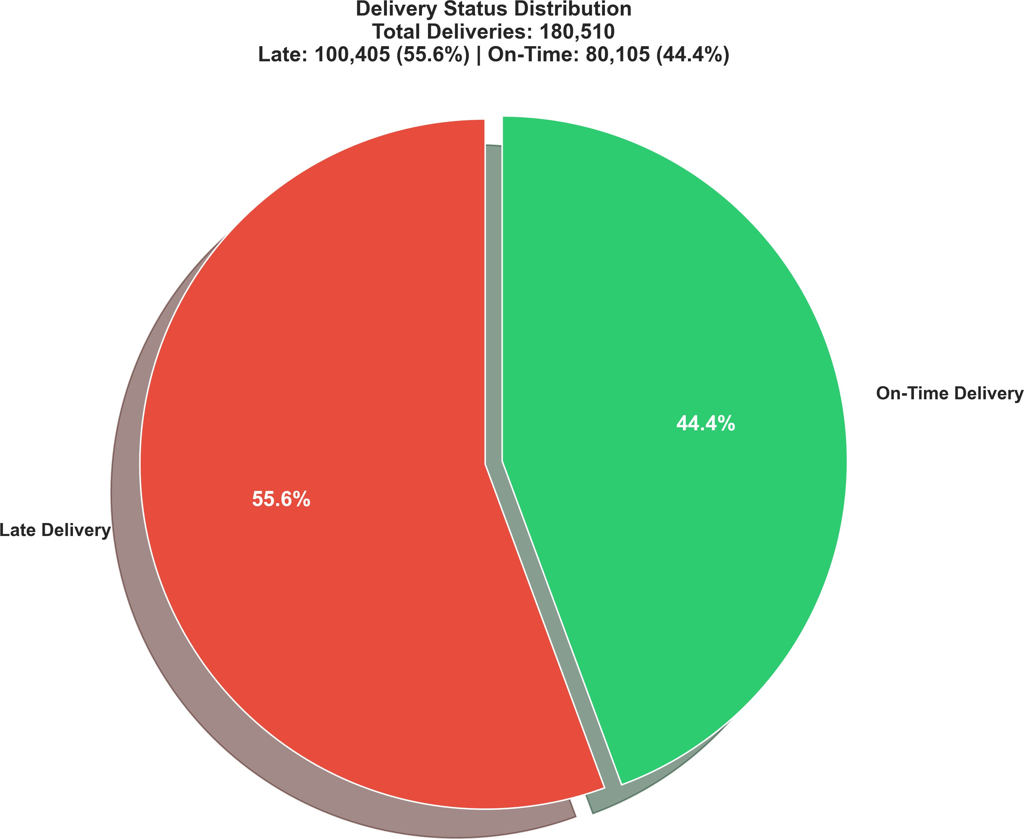

Figure 4: Pie chart showing the predicted late delivery risk

SCM

The Structural Causal Model (SCM) was applied to decompose late delivery risk into mechanism-level contri- butions for each order. Table 2 presents representative orders selected from the dataset to illustrate variation in causal explanations. Only a subset of orders is reported for clarity, while the full results are available in the complete dataset.
The results show that the causal mechanisms of supplier efficiency turn out to be the most dominant across a large portion of the cases of late delivery. This implies the existence of inefficiencies in the supplier-related activities which play a critical role in the occurrence of delivery disruptions. Unlike the supposed mediator influence, what instead emerges is the efficiency of suppliers, which appears quite often as the main factor of influence, suggesting that the upstream operation has a significant direct and indirect impact on delivery results.
The Pareto analysis (Fig. 5) is another way that confirms this observation. The results indicate that the efficiency of the supplier, logistics constraints and delay in execution account for about 80% of the dominant causes in late deliveries. This suggests that a few mechanisms account for most of the occurrences of delays, which is consistent with the Pareto principle. Of these, efficiency of the suppliers account for the highest contribution followed by logistical constraints and delays in execution.

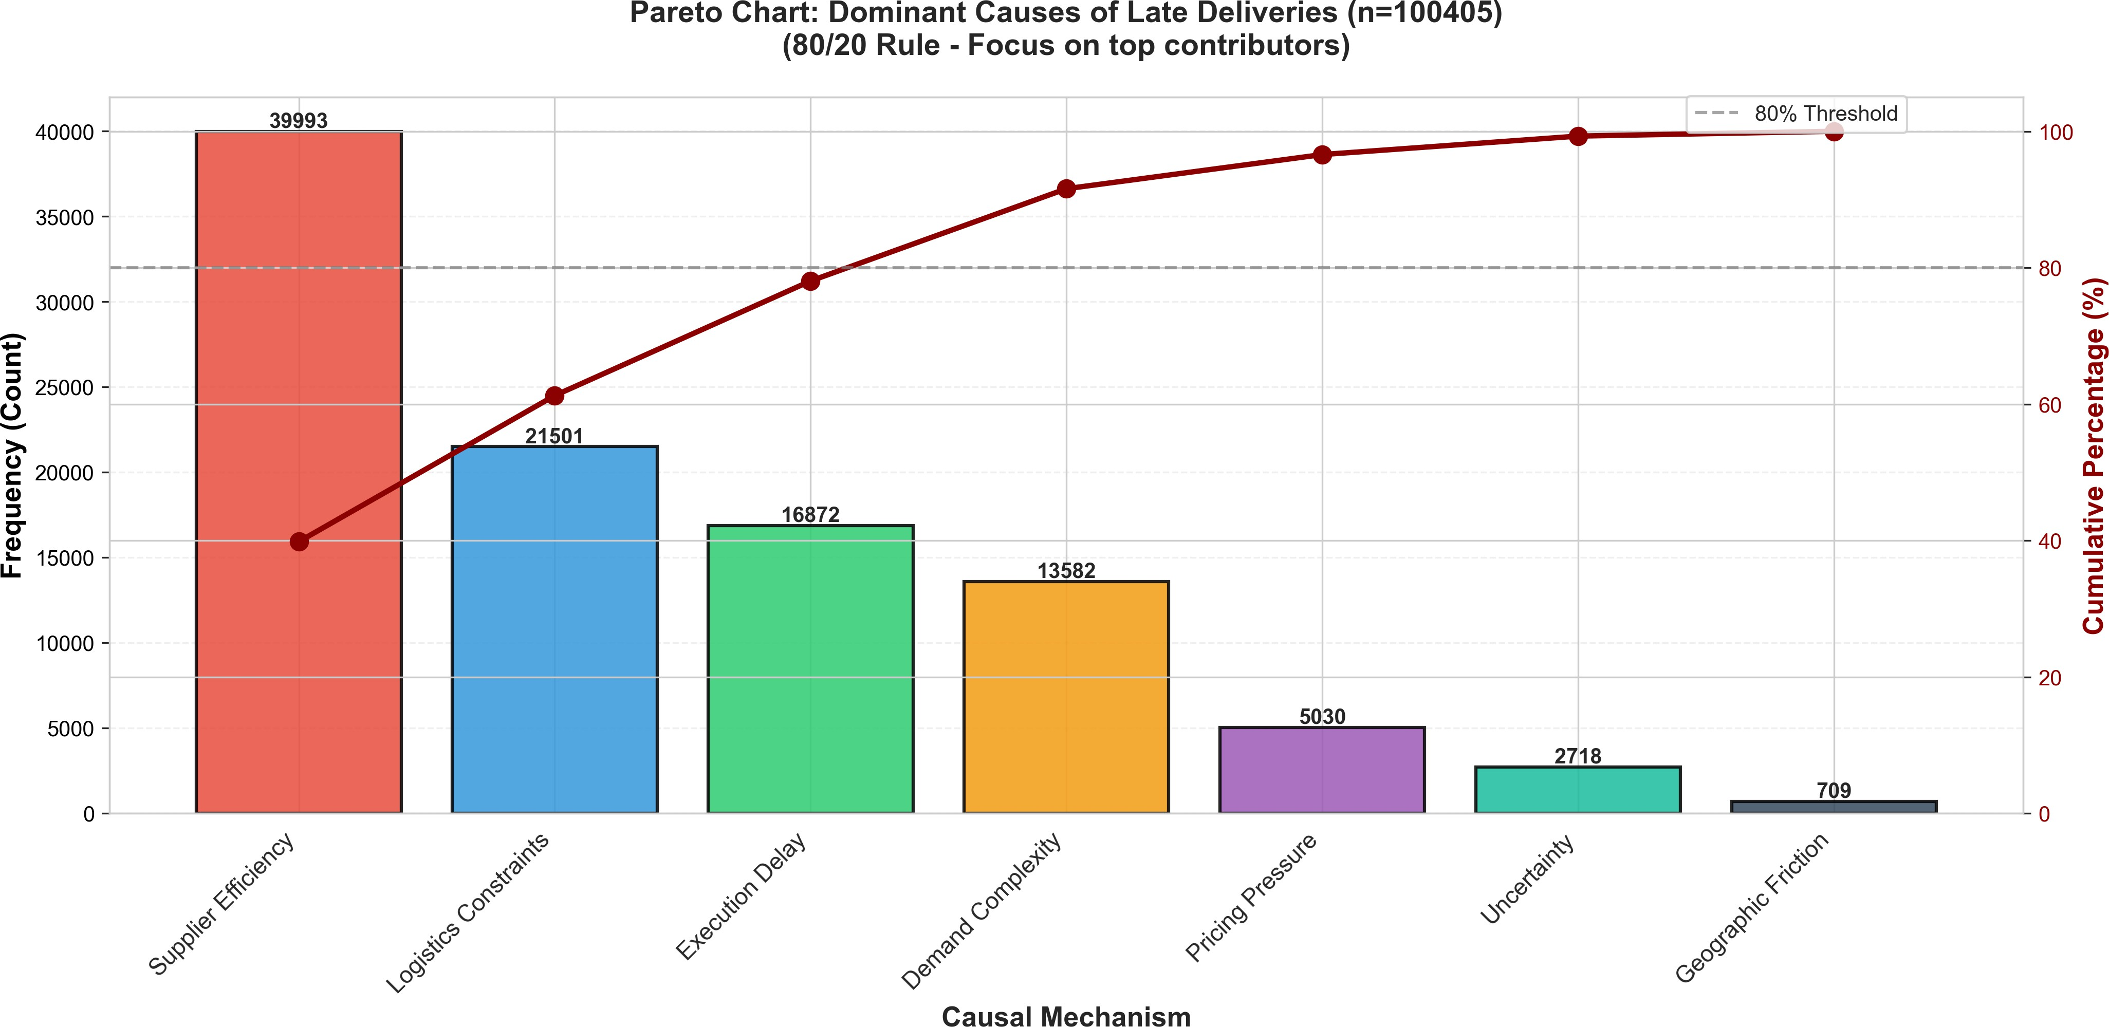

Figure 5: Pareto chart showing the most frequent causes

The ranked horizontal bar chart (Fig. 6) provides additional insight by comparing contribution magnitudes be- tween late and on-time deliveries. The results show that supplier efficiency and logistics constraints are factors in late deliveries. Delay in execution has a very high weight of contribution to timely deliveries while compar- atively low weight to weighted number of late deliveries site. This tells us is that late deliveries are most often attributable to some systemic problems with the way things are run. When deliveries happen on time it is because the people in charge have control over what is going on.
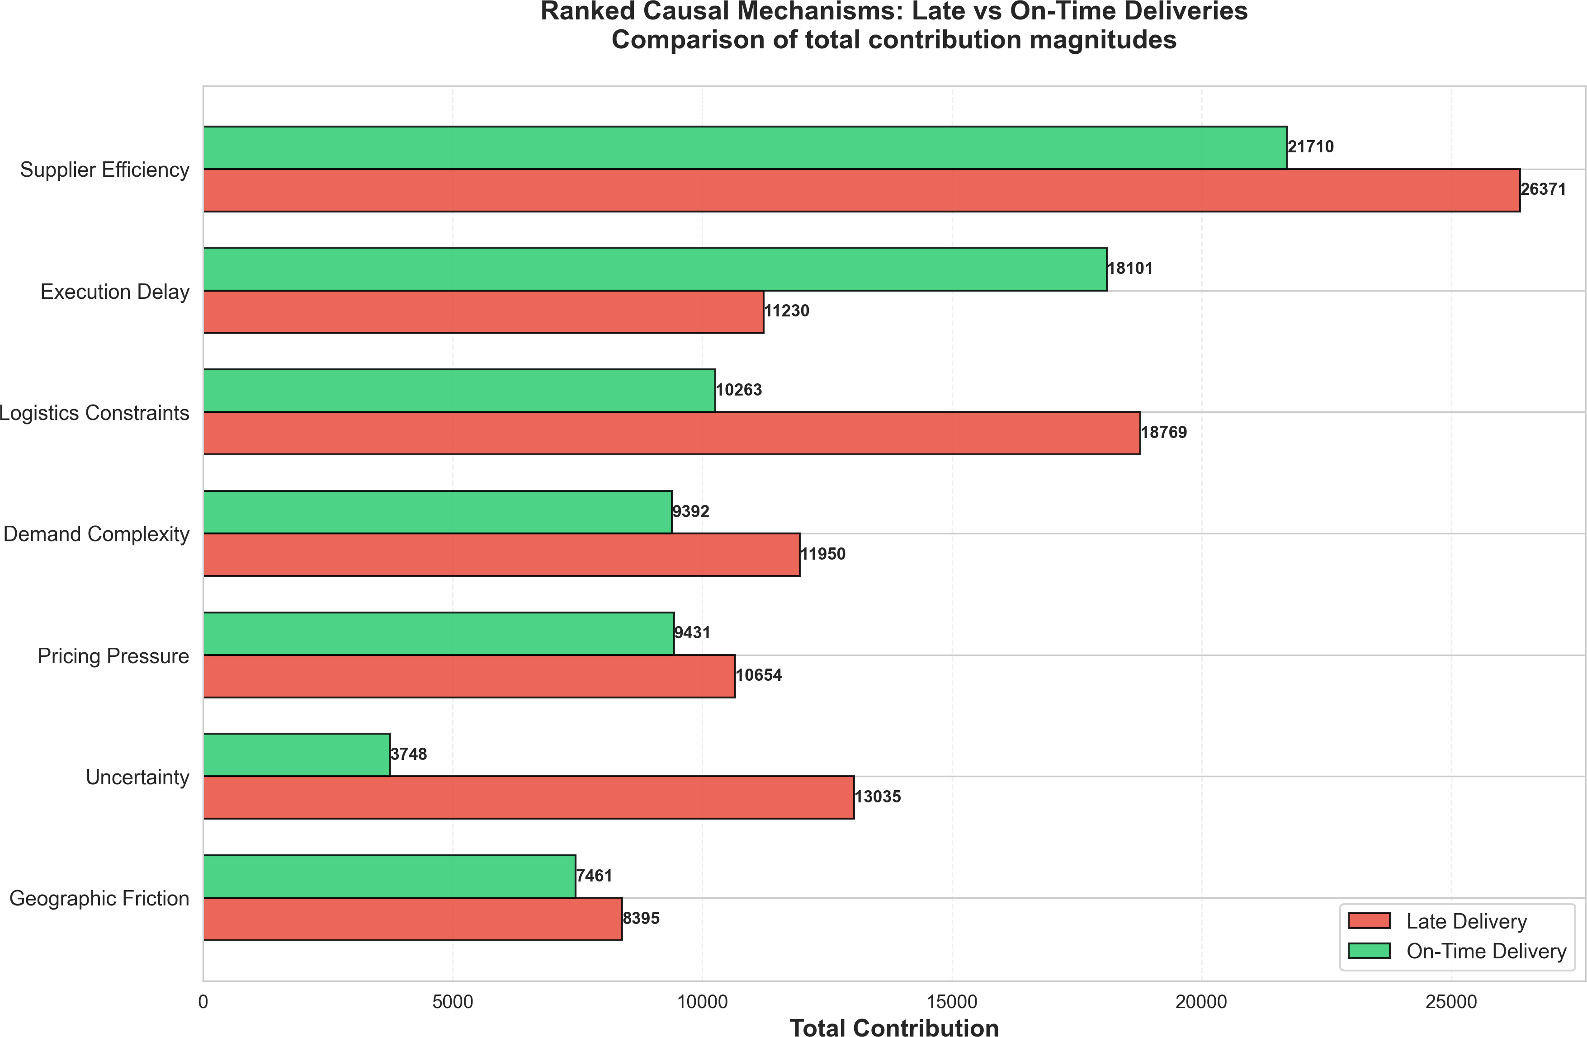

Figure 6: Ranked Horizontal Bar chart comparing contribution between late deliveries and on-time deliveries

The analysis of order-level data shows that different causal mechanisms lead to different results in each transac- tion. The main reasons for late deliveries are supplier efficiency problems and logistics limitations but particular cases are affected by other factors including pricing pressure and geographic friction. The study demonstrates that delivery risk assessment needs to consider specific situations because it requires multiple operational factors to explain risks across different transactions.
The experiments show that SCM delivers understandable explanations which show the specific delivery risk mechanisms of late deliveries. The combination of aggregate analysis (Pareto and ranking) and order-level insights (Table 2) enables a more comprehensive understanding of how operational factors contribute to delivery performance.
To illustrate, when the supplier efficiency is singled out as the leading source of the projected delay risk, the decision makers might concentrate on enhancing the coordination or capacity of suppliers. Shipping mode

changes or consolidations of order are possible to lower delivery pressures when logistics constraints prevail. With this kind of mechanism-level interpretation, intentional operational decision making is possible, not just a mere risk prediction.

Counterfactual Analysis

The study used counterfactual analysis to test which operational interventions most effectively reduced late delivery risk at the order level. Table 3 presents representative examples showing how different intervention strategies affect predicted risk values. The results show that operational changes lead to decreased delivery delay risk but the extent of the benefits depends on the specific operational conditions. The predicted risk for Order ID 49531 decreased from 0.6856 to 0.3465 which represents a reduction of 0.3390. The results indicate that decision-makers can use targeted interventions to determine which delivery reliability improvement areas they should prioritize for reducing delay risks.

Table 3: COUNTERFACTUAL RISK ANALYSIS
Order ID | Original Risk | Counterfactual Risk | Causal Effect | Risk Reduced
65308 | 0.8415 | 0.7522 | 0.0893 | Yes
49531 | 0.6856 | 0.3465 | 0.3390 | Yes
65534 | 0.8395 | 0.7771 | 0.0624 | Yes
29720 | 0.8592 | 0.7784 | 0.0808 | Yes
3353 | 1.0416 | 0.8894 | 0.1522 | Yes

However, the extent of improvement differs from case to case. While some orders have good risk reductions in predictions, others have a comparatively lower improvement, suggesting that intervention effectiveness is an angle of underlying operational conditions. In spite of this variation, all selected cases indicate a reduction of risk, as indicated by the “Yes” in the risk reduction column for all. Overall, these findings suggest the practical relevance of the use of counterfactual reasoning as a decision support tool for identifying where operational changes are likely to lead to lower late delivery risk.

Validation

The validation metrics evaluate the consistency, stability, and structural reliability of the proposed SCM-based explanations rather than predictive accuracy. Unlike predictive evaluation metrics, these measures do not evaluate how accurate a model is, but the quality of an explanation. The framework is evaluated using Counterfactual Consistency Error (CCE), Faithfulness, Sparsity, Domain Alignment and Stability.

Counterfactual Consistency Error (CCE) Counterfactual Consistency Error tests the stability of causal im- pacts for different groups of operation. It quantifies the variation of counterfactual outcomes based on the coef- ficient of variation relative to the supplier efficiency groups which will be represented by Eq. 17.

CCE = mean σ(CE) (17)

|µ(CE)| + ϵ

where σ(CE) is the standard deviation of the distributions of causal effects, µ(CE) is the mean of the distributions of the causal effects, and ϵ is a small constant for numerical stability. The obtained value of 0.0077 gives an

indication of highly consistent counterfactual behavior for the operational conditions.

Faithfulness Faithfulness evaluates how accurately the generated explanations reflect the underlying causal structure of the model. It is computed by measuring the reduction in explanatory power after ablating execution delay from the structural equation, as shown in Eq. 18.

R² − R²
Faithfulness = ^{full} ^{ablated} (18)
2
ablated + ϵ
1 − R

where R²
full
2
ablated
and R
denote the coefficient of determination before and after ablation, respectively. The ob-

tained value of 0.9654 confirms strong alignment between explanations and the structural model.

Sparsity Sparsity measures how concentrated explanations are across causal mechanisms using the normal- ized Gini coefficient. It quantifies whether explanations are dominated by a small number of mechanisms, as expressed in Eq. 19.

Sparsity =
2 Σ r_{i}c_{i}
n Σ c_{i} −
n−1 n

n+1 n

(19)

where c_{i} represents contribution values, r_{i} denotes rank positions, and n is the number of mechanisms. The obtained value of 0.9779 indicates highly concentrated explanations.

Stability Stability evaluates the consistency of explanations across different data splits using cross-fold vari- ance, as expressed in Eq. 20.

Stability = max(mean variance across folds) (20) The obtained value of 0.0005 indicates highly stable explanations across sampling variations.
Domain Alignment Domain alignment evaluates agreement between model-derived mechanism rankings and expert-defined expectations using Spearman’s rank correlation, as shown in Eq. 21. Where d_{i} represents rank differences between model and expert ordering. The obtained value of 0.9800 indicates strong agreement with domain knowledge.

2
6 Σ d
ρ = 1 − ^{i}
n(n2 − 1)
(21)

To evaluate the robustness of the proposed framework, the structural relationships were analyzed under different model inputs and normalization methods. The causal contribution patterns remained consistent across various supplier efficiency distributions and transaction-level operational conditions, suggesting that the identified dom- inant mechanisms are not affected by minor fluctuations in data scaling or coefficient estimation. The stability of explanation rankings across cross-validation folds further indicates that the SCM-based interpretation is not contingent upon a particular sample partition. Further robustness checks, including alternative DEA input con- figurations and nonlinear structural formulations, might yield additional insights; however, the current results

demonstrate that the proposed framework exhibits stable explanatory behavior under the assessed conditions.

CONCLUSION AND FUTURE WORK

The study presents a causal explainability framework for late delivery risk by integrating a modified DEA- TCN prediction model with a SCM. The DEA-TCN component generates continuous supplier efficiency scores together with probabilistic estimates of delivery risk which enable operational performance assessment to remain unchanged throughout different delivery processes. The SCM model establishes relationships among supplier efficiency, demand complexity, pricing pressure, logistics constraints, geographic friction, execution delay while allowing users to understand how different components contribute to prediction results.
The results demonstrate that supplier efficiency and logistics constraints together with execution delay create high delay risk which varies between different operational situations. Counterfactual evaluation shows that targeted adjustments to specific mechanisms can reduce predicted delay risk while the magnitude of improvement differs across orders due to heterogeneity in supply chain conditions. The evaluation metrics show high faithfulness and sparsity and domain alignment and stability while maintaining low counterfactual consistency error which demonstrates that structural explanations match the specified causal connections.
Researchers must recognize specific restrictions which exist as inherent boundaries of their work. The re- searchers used linear modeling to construct structural equations because it allows them to maintain clear un- derstanding of their causal parameters yet actual supply chain systems operate through nonlinear relationships and threshold effects. The study depends on one available public dataset which restricts its ability to apply findings to different industrial sectors and various logistics settings. The established causal mechanisms define main operational areas which include supplier capability and logistics complexity and demand characteristics and geographic factors which exist in manufacturing and retail and healthcare logistics and e-commerce fulfill- ment systems. The research framework will extend its boundaries through future research which will implement nonlinear structural causal models and hybrid explainability methods that combine SCM with feature attribu- tion techniques and through the evaluation of system performance across different parameter configurations and through the validation process which utilizes cross-industry and real-time streaming datasets to enhance its use- fulness in real-world decision-making environments.

REFERENCES

- Pearl J. (2000). Causality: Models, reasoning, and inference. Cambridge University Press.
- Pearl J. (2009). Causality: Models, reasoning and inference (2nd ed.). Cambridge University Press.
- Wang L., Huang S., Wang S., Liao J., Li T., Liu L. (2024). A survey of causal discovery based on functional causal model. Engineering Applications of Artificial Intelligence, 133, 108258.
- Carriero A. (2025). Directed acyclic graph representation of the demand-supply model. Economics Let- ters, 255, 112481.
- Heyn H., Mao Y., Weiss R., Knauss, E. (2025). Causal models for specifying requirements in industrial ML-based software: A case study. Journal of Systems and Software, 232, 112691.
- Riccardi L., Compare M., Mascherona R., Zio E. (2025). Structural causal modeling and STPA for the risk analysis of a rail system. Reliability Engineering and System Safety, 256, 110758.
- Takahashi D., Shimizu S., Tanaka T. (2024). Counterfactual explanations of black-box machine learning models using causal discovery with applications to credit rating. IEEE Access, 12, 12345–12356.

- Jomthanachai S., Wong W.-P., Lim C.-P. (2021). An application of data envelopment analysis and machine learning approach to risk management. IEEE Access, 9, 85978–85994.
- Lin S.-W., Lu W.-M. (2024). Using inverse DEA and machine learning algorithms to evaluate and predict suppliers’ performance in the Apple supply chain. International Journal of Production Economics, 271, 109203.
- Abushaega M., Moshebah O., Hamzi A., Alghamdi S. (2025). Enhancing supply chain resilience with data envelopment analysis and temporal convolutional networks for supplier efficiency and late delivery risk prediction. Alexandria Engineering Journal, 128, 231–246.
- Jin T. (2024). Attention-based temporal convolutional networks and reinforcement learning for supply chain delay prediction and inventory optimization. Proceedings of the International Conference on Image Processing, Computer Vision and Machine Learning, 1527–1531.
- Nimmy S F., Hussain O. K., Chakrabortty R. K., Hussain F. K., Saberi M. (2022). Explainability in supply chain operational risk management: A systematic literature review. Knowledge-Based Systems, 235, 107587.
- Saranya A., Subhashini R. (2023). A systematic review of explainable artificial intelligence models and applications: Recent developments and future trends. Decision Analytics Journal, 7, 100233.
- Retzlaff C. O., Angerschmid A., Saranti A., Schneeberger D., Ro¨ttger R., Mu¨ller H., Holzinger A. (2024). Post-hoc vs ante-hoc explanations: XAI design guidelines for data scientists. Cognitive Systems Research, 86, 101243.
- Gupta R., Patel S. (2024). A comparative study of LIME and SHAP for enhancing trustworthiness and effi- ciency in explainable AI systems. Proceedings of the IEEE International Conference on Machine Learning and Applications, 1–7.
- Ogorodnyk M., Stendal J. A., Leirmo T., Harik E. H. C. (2025). Delivery route optimization with SHAP and LIME: An explainable AI approach. IFAC-PapersOnLine, 58(3), 1120–1126.
- Ogorodnyk O., Stendal J. A., Leirmo T., Harik E. H. C. (2025). Explainable AI for delivery route opti- mization using reinforcement learning. IFAC-PapersOnLine, 59(9), 2136–2140.
- Chen T.-C. T., Wang Y.-C., Wang Y.-C. (2025). An explainable decision model for selecting facility locations in supply chain networks. Sustainable Computing: Informatics and Systems, 11, 100148.
- Pawlicki M., Pawlicka A., Uccello F., Szelest S., D’Antonio S., Kozik R., Choras´ M. (2024). Evaluating the necessity of multiple metrics for assessing explainable AI: A critical examination. Neurocomputing, 602, 128282.
- Dutta G., Sarddar D., Vasumathi B., Kavitha P. (2025). IoT-based real-time intelligent delivery service model for perishable food logistics. International Journal of Applied Mathematics, 38, 1770–1786.

